EXEMPTION CERTIFICATE

BETWEEN 8 PM AND 6 AM
Pursuant to article 4 of the decree n°2020-1310 of October 29th 2020 prescribing rules necessary in the fight against the spread of the Covid-19 virus
I, the undersigned,
Ms/Mr:
Born on:
In:
Address:
certify that my reasons to be outdoors match one of the following situations (check the box) authorised by the official measures to tackle the spread of Covid 19 as part of the state of health emergency¹:
[ ] Commuting to and from work or university and training place, business trips that cannot be delayed
[ ] Consults and provision of care that cannot be done remotely or delayed;
[ ] Imperative family reasons, assisting vulnerable persons, persons in a precarious situation or taking care of children.
[ ] Persons with a disability and their accompanying person
[ ] Judicial or administrative summons
[ ] Participating in a mission of general interest upon request from an administrative authority
[ ] Air or rail transit related to long distance journeys
[ ] Walking a pet outdoors within 1km of one’s place of residence and for a brief amount of time

Signed in
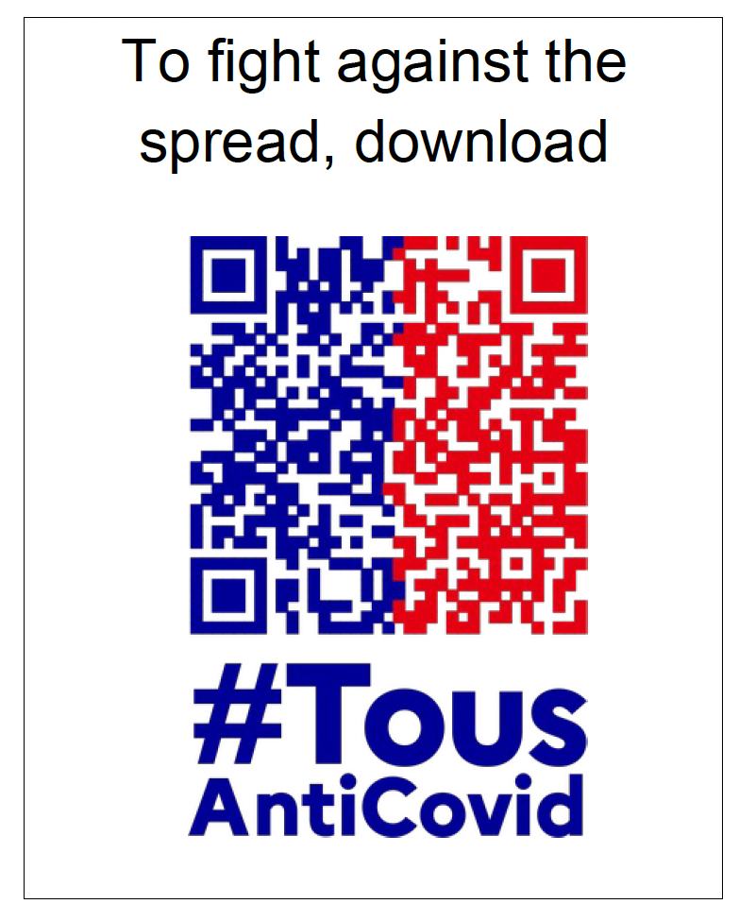
On: at:
(Date and hours are mandatory)

Signature:

1. People whose situation matches one of the aforementioned and can therefore be exempt must carry, when outdoors, written proof to justify that exemption.

